Abstract

When we create any system, service, application, such as web server, database etc. It is important to have the time synced to a main server for consiscency.

**Configuring The NTP Client At The Command Line**

Chrony service

**Configuring The NTP Client At The Command Line**

**Project: NTP => Network Time Protocol**

NTP is as useful on every box as the box itself. Having different time and not properly synced time will only disrupt applications on servers that rely on time such as cron jobs, database files, web-services, rsync/backing up files etc…

Use the below steps to configure the ntp client. (You will need to research on this for latest updates and name changes)

1. Edit the /etc/ntp.conf file.
2. Search for the lines beginning server.

server 0.rhel.pool.ntp.org

server 1.rhel.pool.ntp.org

server 2.rhel.pool.ntp.org

1. Replace the server entries with the IP address or hostname of the NTP server or servers with which you want to synchronize. For example:

server ntp.google.com

OR

server 172.17.1.24

1. Save the file.
2. Configure the NTP client service to start at run level 3 when the appliance boots. Enter:

# /sbin/chkconfig --levels 3 ntpd onsy

1. Check to ensure that this change has been made correctly. Enter the following command and ensure that the output is the same as that shown:

# /sbin/chkconfig --list ntpd

Output: ntpd 0:off 1:off 2:off 3:on 4:off 5:off 6:off

1. Start the service. Enter:

/sbin/service ntpd start

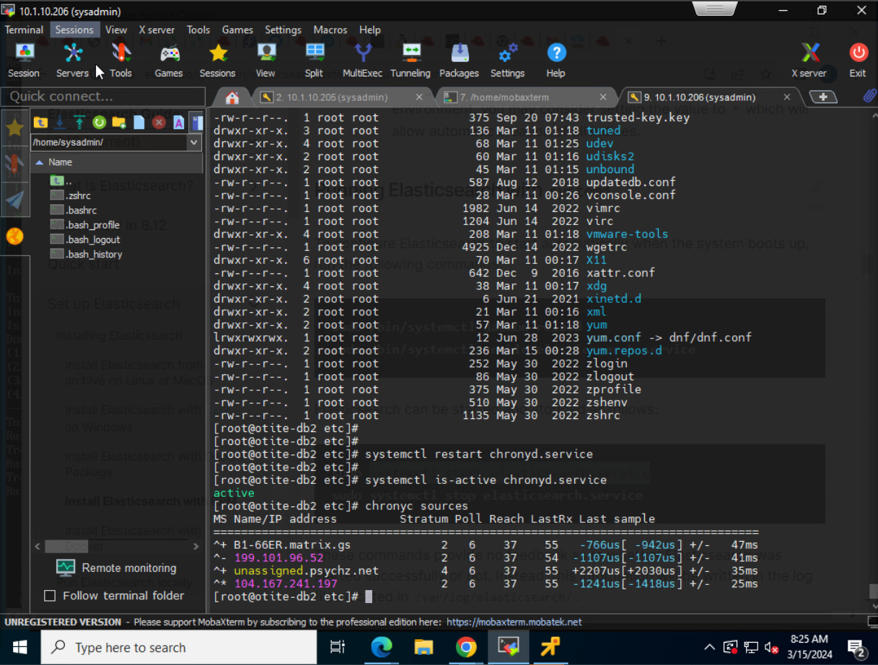

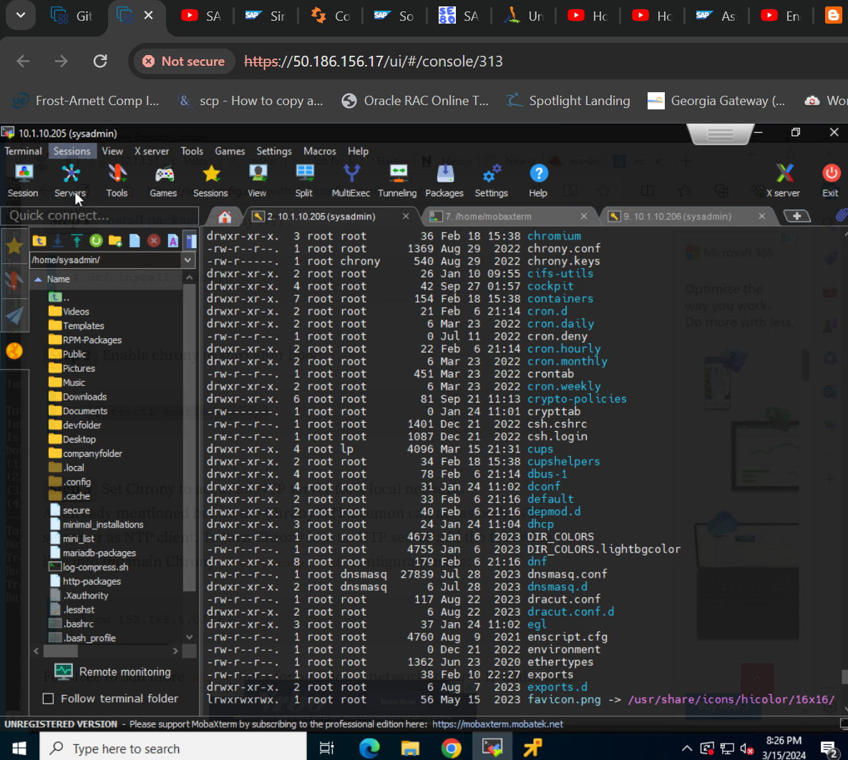

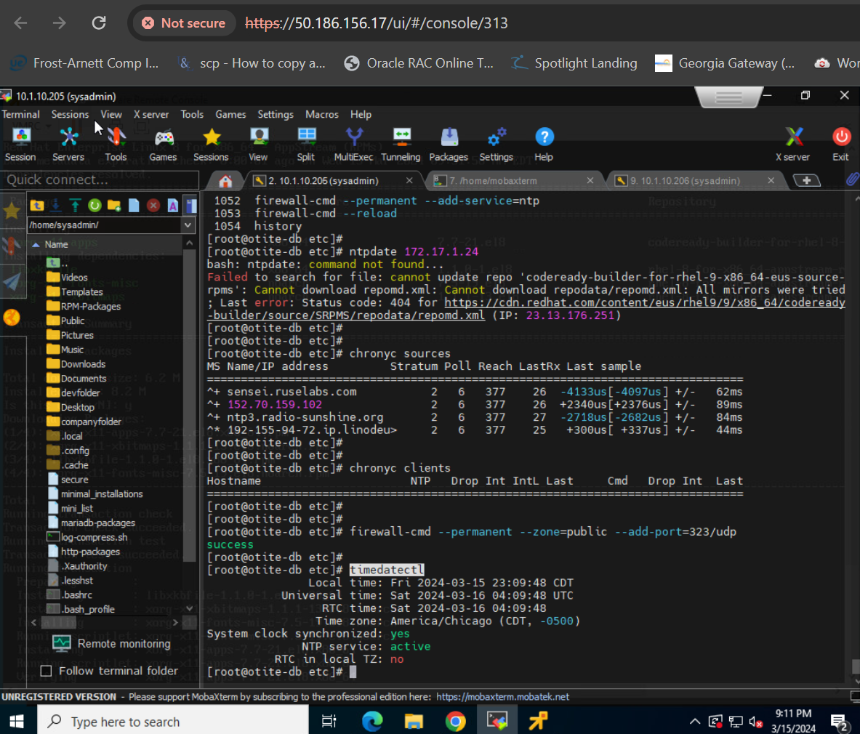

More online source:

To configure Red Hat 8 as an NTP server, you'll primarily use the chrony service. First, you'll need to install chrony, enable it to start on boot, and configure the chrony.conf file to allow access to your network. Finally, you'll restart the service and verify the configuration.

Step-by-step configuration:

1. **Install Chrony:**
   * Open a terminal and use the following command:

Code

*# dnf install chrony*  
 ``` [1, 3]  
  
2. \*\*Enable and Start Chrony:\*\*  
 - Enable chrony to start automatically on boot:  
 ```bash  
 # systemctl enable chronyd

Start the service.

Code

*# systemctl start chronyd*  
 ``` [1, 3]  
  
3. \*\*Configure `chrony.conf`:\*\*  
 - Open the configuration file:  
 ```bash  
 *# vi /etc/chrony.conf*  
 ``` [2, 4]  
 - Add lines to specify allowed networks and servers:  
 - Example: To allow access from your local network (192.168.1.0/24) and use `pool.ntp.org` as a server:

allow 192.168.1.0/24  
server pool.ntp.org iburst

Code

- You can also add specific NTP servers by their IP addresses:

server <server\_ip\_address> iburst

Code

4. \*\*Restart Chrony:\*\*  
 - Apply the changes by restarting the service:  
 ```bash  
 # systemctl restart chronyd  
 ``` [2, 3]  
  
5. \*\*Verify Configuration:\*\*  
 - Check the synchronization status:  
 ```bash  
 # chronyc tracking

Check the time sources.

How to configure NTP server on RHEL 8 / CentOS 8 Linux

24 September 2019 by [Lubos Rendek](https://linuxconfig.org/author/lubos" \o "View all posts by Lubos Rendek)

Chrony is a default NTP client as well as an NTP server on [RHEL 8](https://linuxconfig.org/how-to-install-rhel-8) / CentOS 8. This article will provide you with an information on how to perform an installation and basic configuration of an NTP server or client on RHEL 8.

**In this tutorial you will learn:**

* How to install NTP server on RHEL 8 / CentOS 8.
* How to install NTP client on RHEL 8 / CentOS 8.
* How to open firewall to incoming NTP requests.
* How to configure Chrony as NTP server.
* How to configure Chrony as NTP client.

Software Requirements and Conventions Used

| *Software Requirements and Linux Command Line Conventions* | |
| --- | --- |
| **Category** | **Requirements, Conventions or Software Version Used** |
| System | RHEL 8 / CentOS 8 |
| Software | chronyc (chrony) version 3.3 |
| Other | Privileged access to your Linux system as root or via the **sudo** command. |
| Conventions | **#** – requires given [linux commands](https://linuxconfig.org/linux-commands" \t "_blank) to be executed with root privileges either directly as a root user or by use of **sudo** command **$** – requires given [linux commands](https://linuxconfig.org/linux-commands" \t "_blank) to be executed as a regular non-privileged user |

How to configure NTP server on RHEL 8 / CentOS 8 Linux step by step instructions

The chances are that Chrony is already installed on your RHEL 8 and currently configured as a client. If this is the case then simply jump directly into Step 3. Let’s first setup an NTP server for network eg. **192.168.1.0/24**.

**How to configure an NTP client on RHEL 8 / CentOS 8 Linux step by step instructions**

1. [install package](https://linuxconfig.org/how-to-install-packages-on-redhat-8) Chrony NTP:
2. # dnf install chrony
3. Enable chrony to start after boot:
4. # systemctl enable chronyd
5. Set Chrony to act as an NTP server for a local network.

As already mentioned before the Chrony NTP daemon can act as both, NTP server or as NTP client. To turn Chrony into an NTP server add the following line into the main Chrony **/etc/chrony.conf** configuration file:

allow 192.168.1.0/24

Feel free to add more **allow** lines for additional networks or host IP addresses.

1. Restart Chrony NTP daemon to apply the changes:
2. # systemctl restart chronyd
3. Open [firewall](https://linuxconfig.org/redhat-8-stop-start-firewall) port to allow for incoming NTP requests:
4. # firewall-cmd --permanent --add-service=ntp
5. # firewall-cmd --reload
6. Confirm your NTP server configuration by manual time sync from any host located on the allowed network. Any NTP client should be able to sync against the new Chrony NTP server.

In our case we will use the **ntpdate** command to sync which our Chrony NTP server locate on **192.168.1.150** IP address:

# ntpdate 192.168.1.150

13 Dec 11:59:44 ntpdate[9279]: adjust time server 192.168.1.150 offset -0.031915 sec

How to configure an NTP client on RHEL 8 / CentOS 8 Linux step by step instructions

In this section we will configure an NTP client to time sync with our new Chrony NTP server located on the **192.168.1.150** IP address:

1. Install Chrony NTP package:
2. # dnf install chrony
3. Enable Chrony to start after boot:
4. # systemctl enable chronyd
5. Set Chrony to act as an NTP client

To turn Chrony into the NTP cleint add the following line into the main Chrony **/etc/chrony.conf** configuration file. Change the IP address accordingly to point to your local Chrony NTP server:

Server 192.168.1.150

1. Restart Chrony NTP daemon to apply the changes:
2. # systemctl restart chronyd
3. Check for NTP server sources. Your local NTP server should be listed:
4. # chronyc sources
5. 210 Number of sources = 9
6. MS Name/IP address Stratum Poll Reach LastRx Last sample
7. ===============================================================================
8. ^\* **rhel8.localdomain** 3 6 7 36 -8235ns[-1042us] +/- 5523us

By default the Chrony NTP client will perform a time synchronization in every 64 seconds.

1. Check NTP client list on the NTP server:
2. # chronyc clients
3. Hostname NTP Drop Int IntL Last Cmd Drop Int Last
4. ===============================================================================
5. ntp-client.localdomain 7 0 10 - 48 0 0 - -